Instructions to authors for the preparation of final paper for publication (max 12 pages)
The title of the paper is typed 16 pt, bold, the initial capitalized only and centered at the top of the page.

Your Name(s)
Your affiliation, address,
postal code, City, Country
Phone: +xx xxx xxxx xxx, Fax: +xx xxx xxxx xxx, your_email@xxx.org
The name of the author(s) is typed 12 pt bold centered in upper and lower case letters.
Affiliation(s) and complete address(es) are typed 12 pt centered in upper and lower case letters.

===Explanation of template starts from here. ===
This is a template of full paper for the Debris Mitigation Competition.

Please submit your manuscript as a WORD file and a PDF file by email to DMC office (dmc@unisec-global.org). Note that only submissions in the English language will be accepted.

The paper should not exceed 12 pages in total length and should strictly adhere to the following outline and formatting guidelines.

==Explanation ends. Please delete this part when you submit. ==

Abstract: A one paragraph abstract, of not more than 300 words, must be included at the beginning of the paper. It should be a summary (not an introduction) and complete in itself. The abstract should indicate the subject dealt with in the paper and should state the overview of your mission idea. Readers should not have to read the whole paper to understand the abstract.

1. INTRODUCTION

In this section, describe the introduction for your idea on the deorbiting device or active removal process/method that you propose. Literature review should be included here.

1.1 Paper Title

The title of the paper is typed 16 pt, bold, the initial capitalized only and centered at the top of the page. The name of the author(s) is typed 12 pt bold centered in upper and lower case letters. Affiliation(s) and complete address(es) are typed 12 pt centered in upper and lower case letters.

1.2 Headings

Headings of the sections are typed 12 pt in capital letters, placed flush left. Subheadings and sub-subheadings are typed 12 pt in bold upper and lower case letters placed flush left.

1.3 Footnotes

Footnotes should appear only, if absolutely necessary. Footnotes are typed 10 pt.

1.4 Illustrations and Captions

Keep in mind, please, that all figures and graphs will be reproduced exactly as you submit them (black and white). Therefore, make sure to provide them in an adequate quality. Place captions, numbered in their respective order, beneath the figures and above the tables, as shown in Table 1 and Fig. 1.
Table 1 Font sizes for papers
Font Size | Appearance (in Time New Roman or similar looking fonts)
Font Size | Regular | Bold | Italic
16 |  | title
12 | author email, address and affiliation | Author name(s)  Headings (in capital letters),  Subheadings and  Sub-subheadings (in upper and lower case letters)
11 | cell in a table | table caption,  figure caption
10 | reference item  abstract body | abstract heading | reference item (partial)

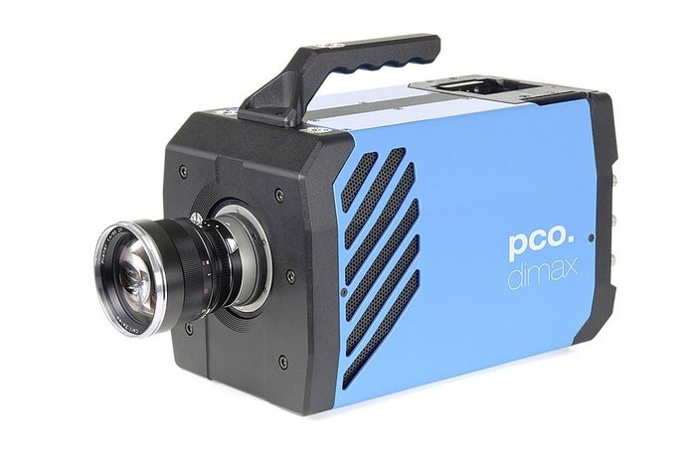
Fig. 1 Example of an unacceptable low-resolution image

1.5 Symbols and Abbreviations

Use only standard symbols in text and illustrations. Unusual units and abbreviations should be defined the first time they are used.

1.6 Equations

The numbers identifying equations should be placed in parentheses on the right. Please, make sure that no ambiguities arise as follow

$q\left(t\right)=2\sqrt{\frac{ρ\text{ck}}{π}}\sum_{i=1}^{m}{\frac{T\left(t_{i}\right)−T\left(t_{i−1}\right)}{{\left(t_{m}−t_{i}\right)}^{1/2}+{\left(t_{m}−t_{i−1}\right)}^{1/2}}}$ (1)

1.7 Sections

The manuscript should be divided into sections, subsections and sub-subsections with clearly marked subtitles (in accordance to instructions in section 1.2 above) and numbered numerically (e.g. 2.1.3). Type the main body of the text single-spaced, beginning flush left. Leave one blank line between paragraphs and between paragraphs and headings/sub-headings.

1.8 Fonts

If possible, the font Times New Roman, 12 pt, or similar looking fonts should be used.

1.9 Page Numbers

Do not apply page numbering.

2. TECHNOLOGY DESCRIPTION (PLEASE CHANGE IT)

Please describe your idea
If possible, the font Times New Roman, 12 pt, or similar looking fonts should be used.

3. DESIGN CRITERIA

Please answer to the following seven evaluation criteria of the competition.
If possible, the font Times New Roman, 12 pt, or similar looking fonts should be used.

3.1 Originality

Please explain what is original in the idea.

3.2 Cost

Please show the cost of the device to prove that the device is affordable

3.3 Technology feasibility – Mechanical and electrical design

Please describe the detail of the mechanical and electrical design to show the deorbiting device or active removal process/method is designed to function properly.

3.4 Effectiveness

Please explain how effectively and how fast the deorbiting device or active removal process/method can make the satellite deorbit .

3.5 Reliability

Please show how the deorbiting device or active removal process/method is designed to fail with a low probability.

3.6 Debris risk

Please estimate the risk that the deorbiting device or active removal process/method produces additional debris, especially, explain how it will function even if the satellite main system has problem in functioning.

3.7 Impact on/for satellite

For PMD: Please show how the deorbiting device (power, mass, weight, etc.) is suitable for 50kg Micro satellite, i.e. it does not give significant impact on the satellite.
For ADR; Please show how the active removal process/method is suitable for removal of a uncooperative 50kg Micro satellite (e.g. a dead satellite).

4. CONCLUSION

Describe the conclusion. If you need to mention “Acknowledgement,” please include in this part.

5. REFERENCES

References to published literature should be quoted in the text in brackets and grouped at the end of the paper in numerical order, typed 10 pt and presented as follows:

[1] J. K. Knowles and E. Reissner, Note on stress-strain relations for thin, elastic shells. J. Math. Phys. 37, 269-282 (1958)
[2] H. S. Carslaw and J. C. Jaeger, Operational Methods in Applied Mathematics, 2nd edition. p.121. Oxford University Press, London (1953)
[3] Authors’ Guidelines. Available online at: www.dlr.de/iaa.symp (accessed August 2015)

